Task 1 : Write a query which uses join and let us know the internal processing of the query.
Query:- select student.s_name ,marks.score,details.school_id from student inner join marks on student.s_id=marks.s_id inner join details on details.school_id=marks.school_id where student.s_id=3;
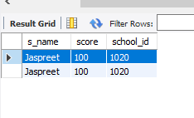
Order of Execution:-
Parsing
Step 1 :- Syntax Check
Step 2 :- Semantic Check
Step 3 :- Shared Pool Check
Step 4 :- Code Optimization
Step 5 :- Row Source Generation
Step 6 :- Execution
Order of Execution with Referance of above Query:
Step 1- From Clause Should get executed first to list the table and also person join on tables.
Query:- select student.s_name ,marks.score,details.school_id from student inner join marks on student.s_id=marks.s_id inner join details on details.school_id=marks.school_id where student.s_id=3;
Step 2- Where Clause executed after from clause to filter data on given condition .
Query:- select student.s_name ,marks.score,details.school_id from student inner join marks on student.s_id=marks.s_id inner join details on details.school_id=marks.school_id where student.s_id=3;
Step 3- Suppose we also have Group by in our query then after the where clause group by executed after where clause.
Query:- select student.s_name ,marks.score,details.school_id from student inner join marks on student.s_id=marks.s_id inner join details on details.school_id=marks.school_id Group by s_name;
Step 4- After Group by the Having which is like where clause but it get executed after the group By clause.
Step 5- After all this execution the Select statement get executed to display the output of query we can also define limited column which we want to display.
Step 6- At last Order by get executed to set the Order of output data in Asecending or Descending form.
Query:- select student.s_name ,marks.score,details.school_id from student inner join marks on student.s_id=marks.s_id inner join details on details.school_id=marks.school_id order by s_name;

Task 2 :- Write a query to calculate the age based on the date of birth value given in the column.
Table Creation:- create table user (name varchar(20), dob date);
insert into user values("Vinod",19990331),("Satish",19970212),("Arush",19950331);
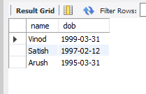
Query to Calculate Age:-
SELECT name , DATE_FORMAT(FROM_DAYS(DATEDIFF(now(),dob)), '%Y')+0 AS Age from user ;
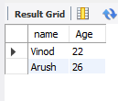
Task 3:-
Write a query which demonstrates date related functions.[Minimum 15].
insert into user value("Satish" ,19990331,1),("Arush" ,19970420,2),("Vinod" ,19980321,3);
select * from user;
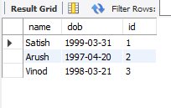

- Select now()-> Return current date and Time.
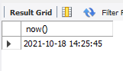
- Select curdate()-> Return Current date.
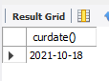
- Select curtime()-> Return Current Time.
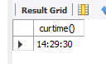
- DATE(): Extracts the date part of a date or date/time expression.
SELECT Name, date(dob) AS BirthDate FROM user;
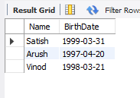
- EXTRACT(): Returns a single part of a date/time.
SELECT Name, Extract(DAY FROM dob) AS BirthDay FROM user;
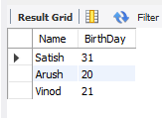

- DATE_ADD() : Adds a specified time interval to a date.
SELECT Name, DATE_ADD(dob, INTERVAL 1 YEAR) AS BirthTimeModified FROM user;
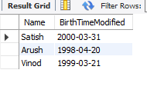
- DATE_SUB(): Subtracts a specified time interval from a date.
SELECT Name, DATE_SUB(dob, INTERVAL 1 YEAR) AS BirthTimeModified FROM user;
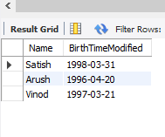

- DATEDIFF(): Returns the number of days between two dates.
SELECT DATEDIFF('2017-02-13','2017-01-03') AS DateDiff;
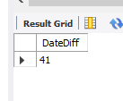
- DATE_FORMAT(): Displays date/time data in different formats.
SELECT DATE_FORMAT('1997-10-04 22:23:00', '%W %M %Y');
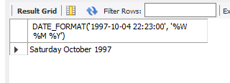

- DAYNAME(date):- Returns the name of the weekday for date.
SELECT DAYNAME('1998-02-05');
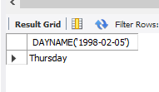
- DayOfMonth(Date):- Returns the day of the month for date, in the range 0 to 31.
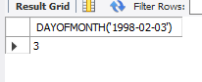

- DayOfWeek(Date):- Returns the weekday index for date (1 = Sunday, 2 = Monday, ., 7 = Saturday). These index values correspond to the ODBC standard.

SELECT DAYOFWEEK('1998-02-03');
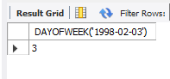
- DayOfYear(Date):- Returns the day of the year for date, in the range 1 to 366.
SELECT DAYOFYEAR('1998-02-03');
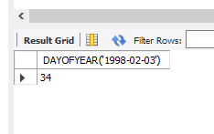
- MakeDAte(year,dayofyear):- Returns a date, given year and day-of-year values. The dayofyear value must be greater than 0 or the result will be NULL
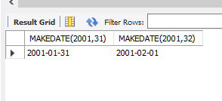

- MakeTime(hour,minute,second):- Returns a time value calculated from the hour, minute and second arguments.
SELECT MAKETIME(12,15,30);
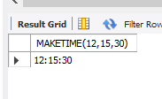

Task 4 :- Write a query to check the current running processes.
show processlist;
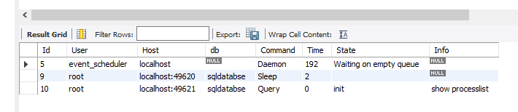

Task 5 :- Write a query to insert values in a specific table of your choice in which one of the column has unique constrains and if one tries to insert data which is duplicate
based on the column having unique constrain then the value gets updated.
insert into student values("1","Satish") on duplicate key Update s_id=10 ;
select * from student;
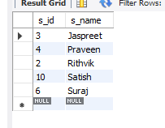

Task 6:- Write Queries which include inner joins along with subqueries.
select student.s_name,marks.score from student inner join marks on student.s_id=marks.s_id where marks.score in (select score from marks where score >90 );
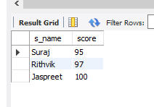

Task 7 :- Deadlock.

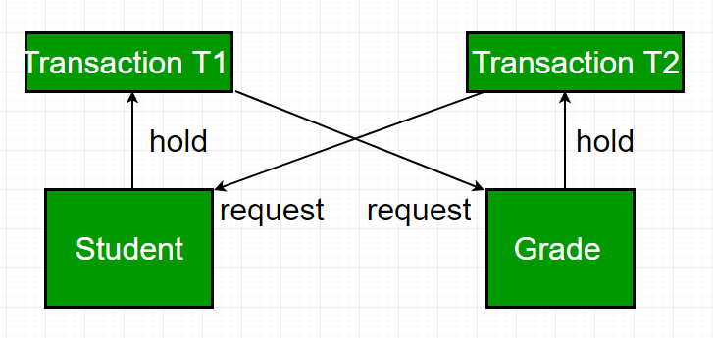

How to Avoid Deadlock:-
- Deadlock Detection – When a transaction waits indefinitely to obtain a lock, The database management system should detect whether the transaction is involved in a deadlock or not.
- Wait-for-graph
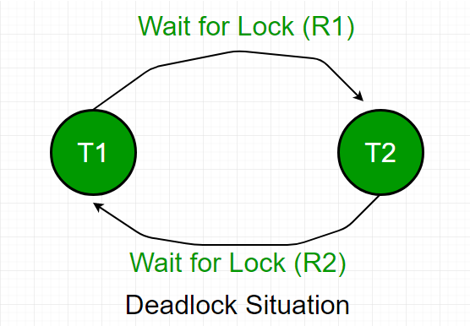
- Deadlock prevention – For a large database, the deadlock prevention method is suitable. A deadlock can be prevented if the resources are allocated in such a way that deadlock never occurs. The DBMS analyzes the operations whether they can create a deadlock situation or not, If they do, that transaction is never allowed to be executed.
- Wait-Die Scheme –
- Wound Wait Scheme –

